**What is a cybersecurity trend?**

A cybersecurity trend is a recurring pattern, technique, technology, or shift in attacker behavior, defender strategy, industry practice, or market adoption that affects how organizations secure systems and data over time. Trends can be technical (e.g., malware targeting firmware), organizational (e.g., adoption of Zero Trust), economic (e.g., rising costs of breaches), or workforce-related (e.g., talent shortages). Tracking trends helps security practitioners prioritize investments, update skills, and design controls that address emerging risks rather than only historical threats.

**Task 1.1 — Cybersecurity Trends Deep Dive**

# Trend 1 — Supply Chain Attacks

**The Problem:** Supply chain attacks exploit trust and access relationships between organizations and their vendors, suppliers, or third-party software providers. Instead of targeting a welldefended enterprise directly, attackers compromise a less-secure vendor (software library, managed service, or contractor) and use that trusted connection to pivot into customer networks. Modern supply chains are complex (multiple tiers), making visibility and control difficult; malicious code can be injected at build time, during delivery, or via third-party service credentials. This weak-link problem turns widely used components or services into force multipliers for attackers.

**The Impact:** For small businesses, a vendor compromise can be catastrophic even if their own defenses are adequate — they can be hit inadvertently through a popular third-party service and lack resources for rapid containment or legal/regulatory response. For large enterprises, supply chain compromises can cascade into broad, expensive breaches affecting millions of customers, trigger regulatory scrutiny (e.g., NIS2, sector rules), and damage brand trust. High-profile incidents show that a single compromised vendor or library can affect thousands of downstream organizations simultaneously.

**The Solution:** Practical defenses include rigorous third-party risk management (TPRM): inventorying vendors, continuous monitoring of vendor security posture, contractual security requirements, and incorporating incident response into vendor programs. Technical measures include requiring SBOMs (software bill of materials), strong code-signing and supply-chain integrity checks, isolation/segmentation of vendor-accessible systems, and frequent verification of dependencies and CI/CD pipelines. For a beginner building skills: practice performing a small vendor risk assessment, learn how to read an SBOM, and experiment with a local CI/CD pipeline to see where dependencies are pulled.

# Trend 2 — Zero Trust (Identity-centric security)

**The Problem:** Legacy perimeter-based security models assume that internal network traffic is more trustworthy than external traffic; that assumption breaks down with cloud adoption, remote work, and third-party access. Attackers who get inside the network or compromise identities can move laterally. Zero Trust reframes the problem: “never trust, always verify” — every user, device, and session requires continuous authentication and authorization, and least-privilege is enforced everywhere. Implementing Zero Trust can be technically and organizationally challenging because it requires identity, device posture, micro segmentation, and strong telemetry working together.

**The Impact:** Enterprises with complex, distributed environments get the most immediate value from Zero Trust: it reduces lateral movement, limits the blast radius of compromised credentials, and supports secure cloud migrations. Smaller organizations also benefit because Zero Trust encourages focusing on identity and access management — high-impact controls even when budgets are limited — but they may implement only parts of the model (e.g., stronger MFA and conditional access) due to resource constraints. Adoption is growing: many organizations report partial or full Zero Trust implementations.

**The Solution:** Start with identity and access controls (MFA, conditional access, least privilege), then add device posture checks, micro segmentation for sensitive apps, and continuous logging/monitoring tied to automated response playbooks. For a beginner: set up a lab with a small app, enable MFA, test conditional access rules, and document the policy decisions in your portfolio. Study case studies and Gartner/Forrester guidance to see realistic phased rollouts.

# Trend 3 — Cybersecurity Skills Gap (Talent shortage & upskilling)

**The Problem:** Demand for cybersecurity talent far outstrips supply. Organizations report vacancies across many security roles (analysts, engineers, incident responders), which creates coverage gaps in monitoring, threat hunting, and secure engineering practices. This shortage means security teams are more likely to be overwhelmed, to slow down detection/response, or to rely on misconfigured or outdated controls. Bulging workloads also increase burnout and turnover, perpetuating the shortage.

**The Impact:** Small organizations often cannot hire dedicated specialists and may rely on generalist IT staff or outsourced services — increasing residual risk. Enterprises may have teams but struggle with prioritization and scaling advanced capabilities (threat hunting, CI/CD security). Studies link staffing shortages to higher breach costs and longer recovery times; talent gaps therefore translate into measurable financial risk. Market analyses in 2025 put the global talent shortfall in the millions of roles, making this a systemic risk to cybersecurity resilience.

**The Solution:** Mix people, process, and technology: expand training and apprenticeship pipelines, use automation and SOAR tools to reduce repetitive analyst tasks, and consider managed detection/response (MDR) where in-house hiring is not feasible. For learners: chart a learning path (fundamentals → hands-on labs → certifications → projects), contribute to opensource security tools or build a small detection rule set, and document those projects in your portfolio to demonstrate practical ability. Employers should also invest in internal training and partnerships with universities/bootcamps.

**Task 1.2 — Infographic**

**Three key data points (for the infographic / portfolio)**

1. **Supply Chain:** More than **70%** of organizations reported at least one material third-party cybersecurity incident in the past year (2025 survey).
2. **Zero Trust Adoption:** Around **63%** of organizations had partially or fully implemented Zero Trust strategies (Gartner, 2024).
3. **Skills Gap:** The global cybersecurity workforce gap reached roughly **4.8 million** unfilled roles (2025 estimates).

I generated a clean, single-page infographic that summarizes the three trends, includes a title, short phrases, one stat per trend, and a concluding takeaway/action item.

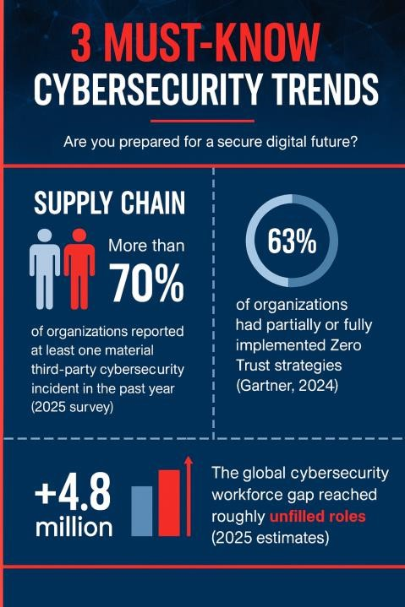

**Phase 2: Virtualization Lab Setup (The "How"**)

Task 2.1: Select and Install Virtualization Software 1. Choose Platform: Oracle VirtualBox Download page

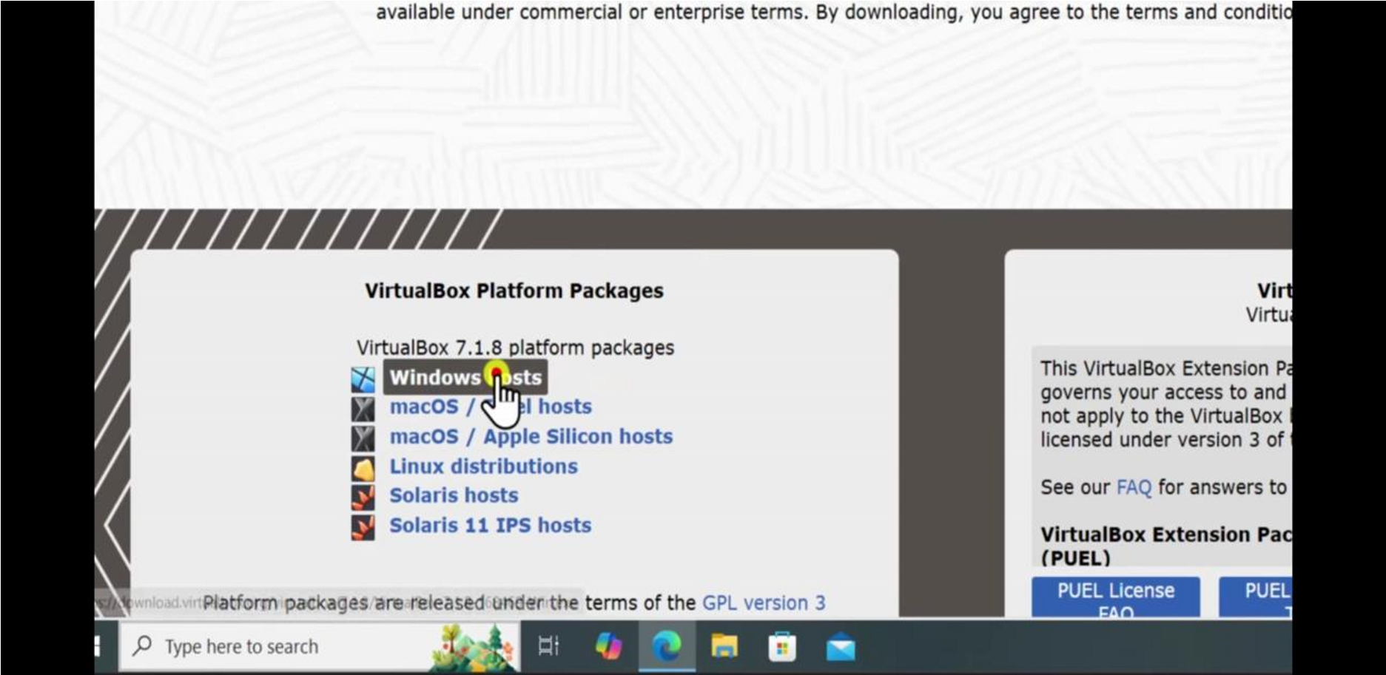

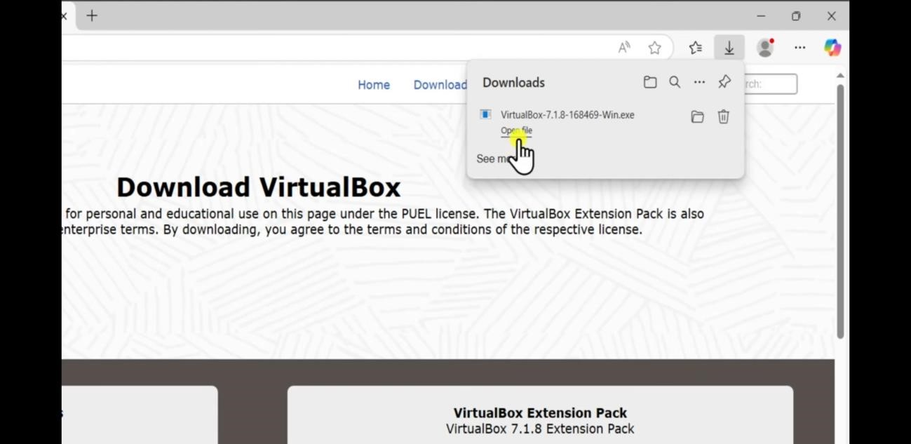

Installer welcome screen

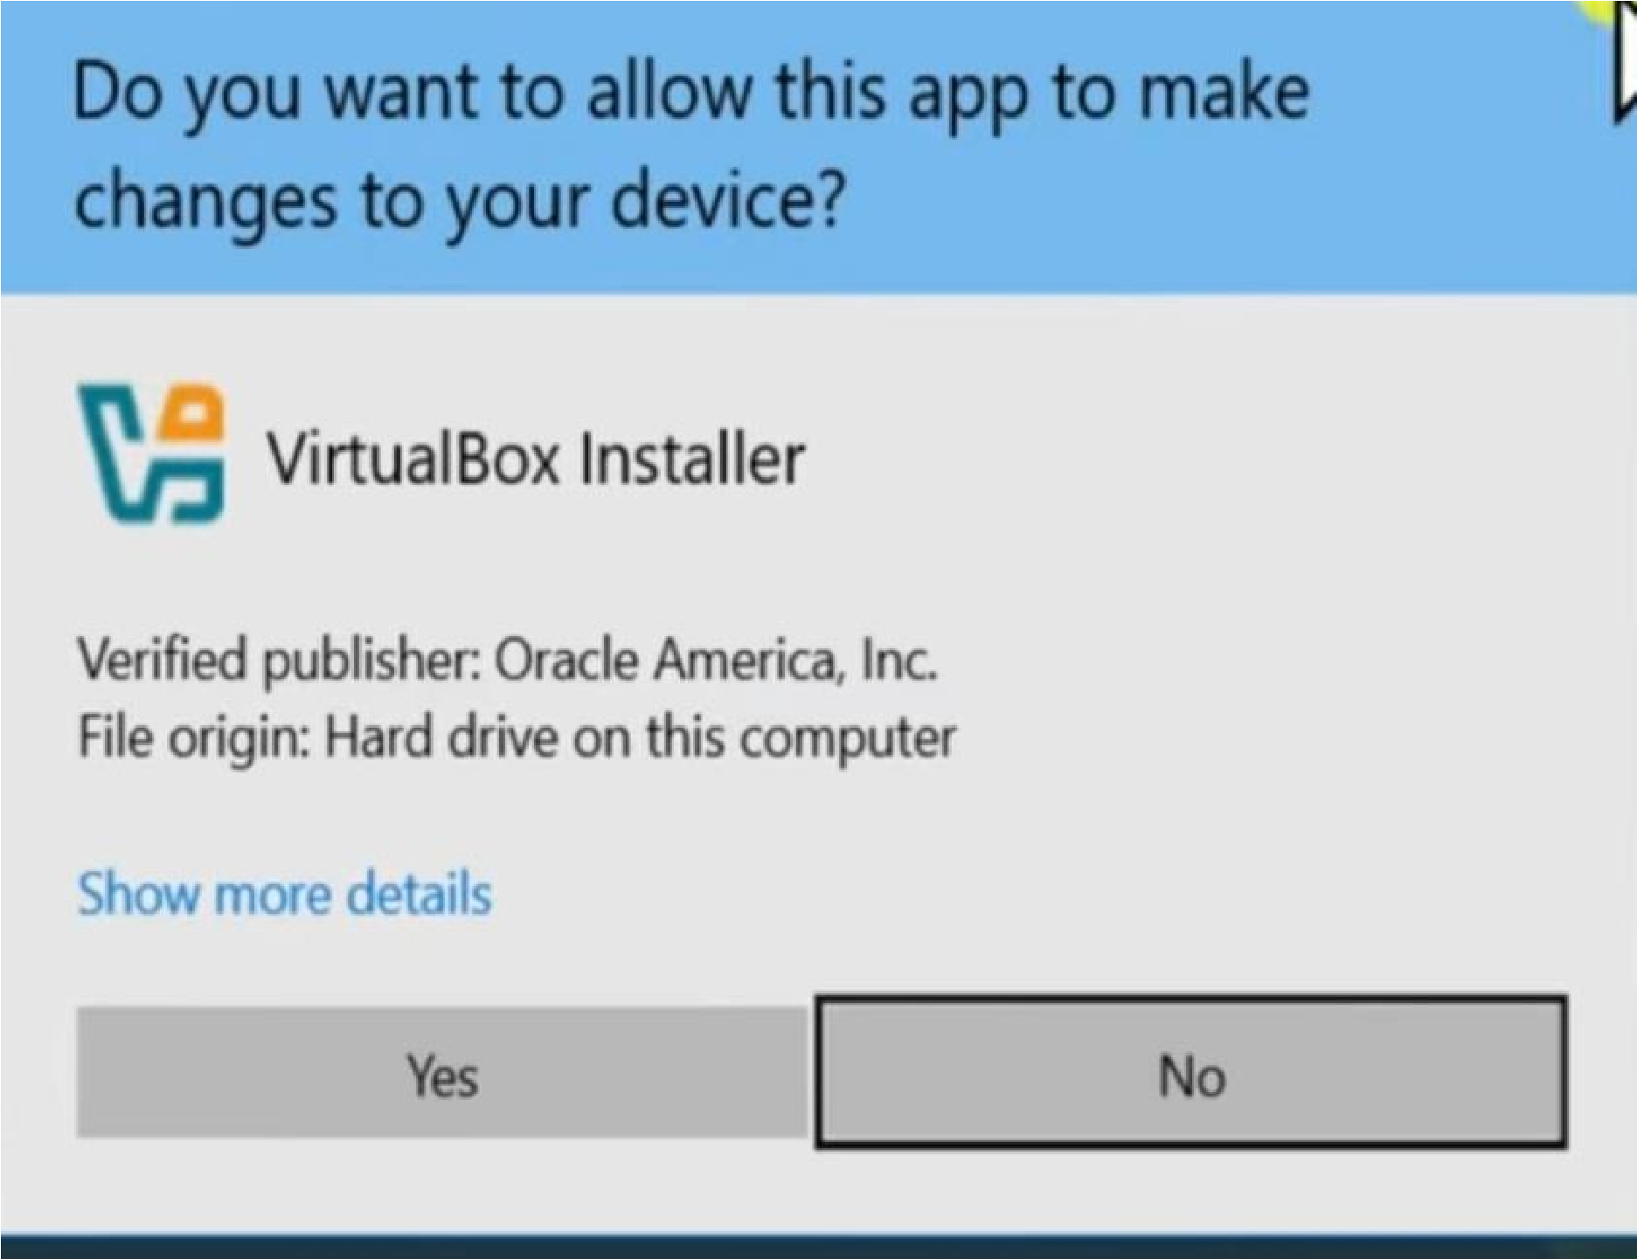

Successful final window

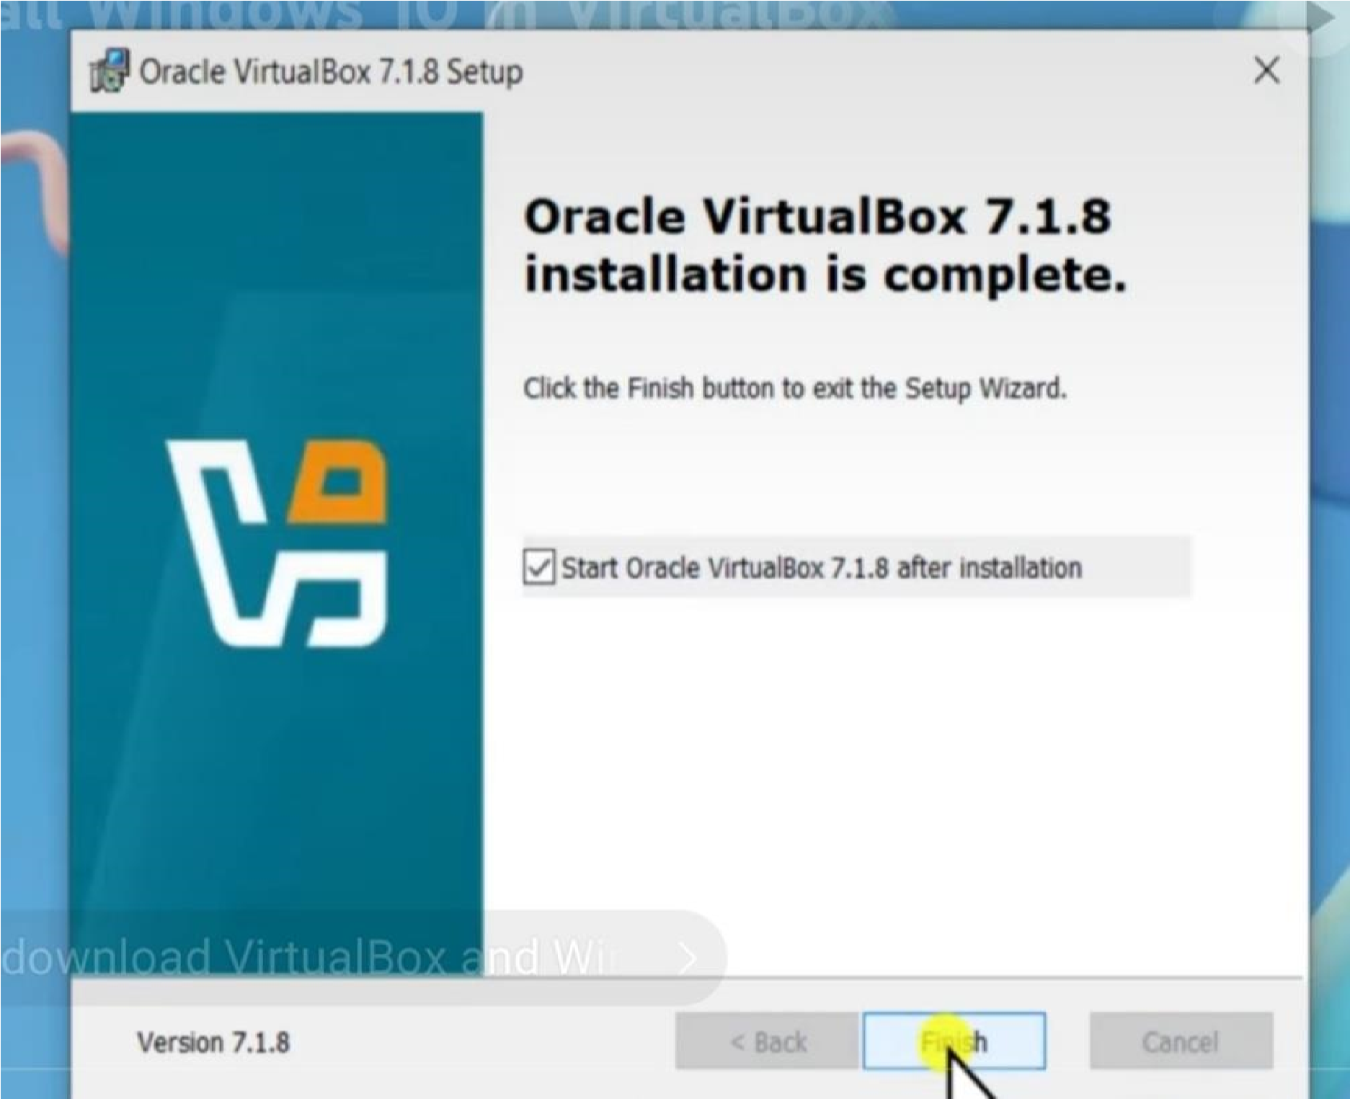

Task 2.2: Ubuntu VM Installation: The Ubuntu installation process

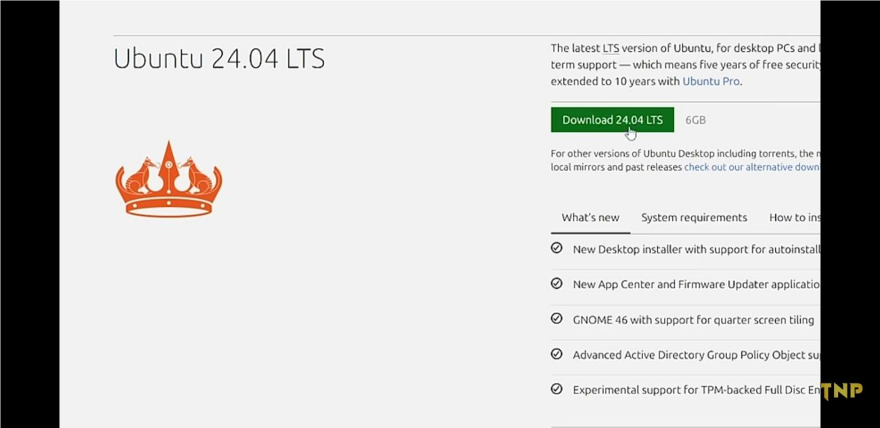



Final running desktop screen

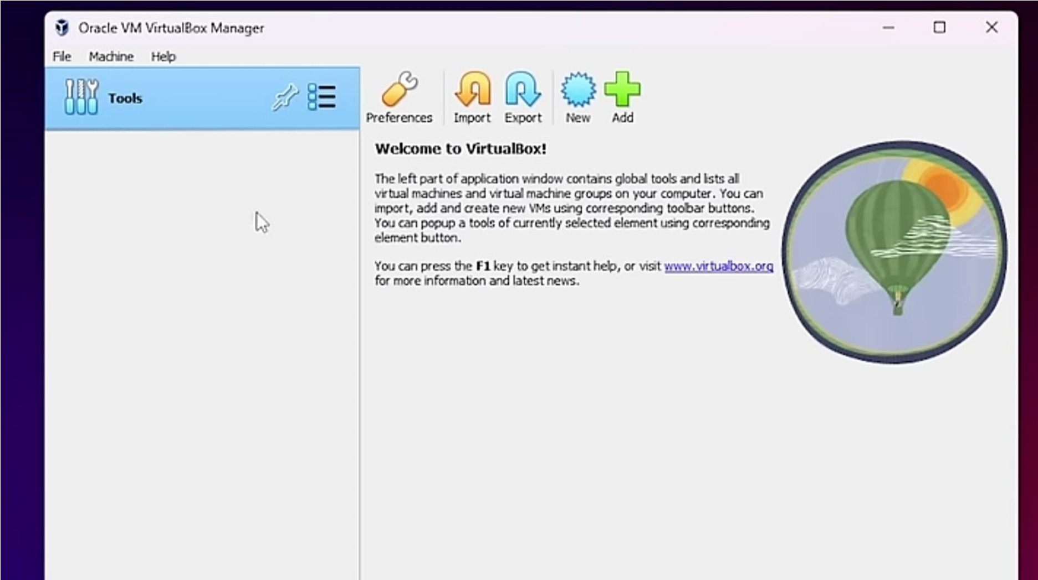

Phase 3: Foundational Linux Skills (The "Practice")

Task 3.1: Essential Linux Commands Walkthrough